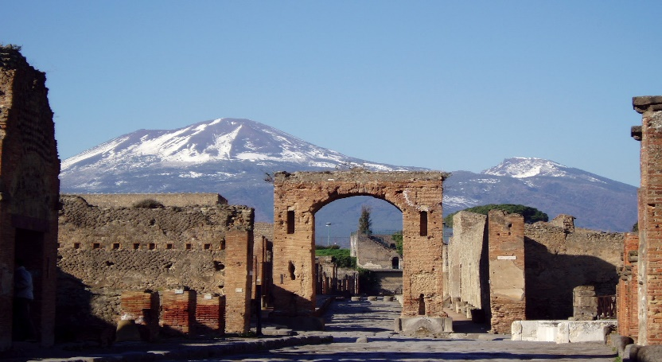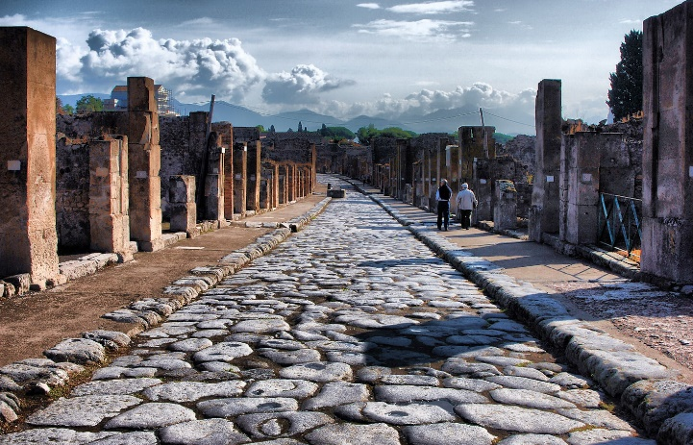

# Pompeii

**Pompeii** ([/pɒmˈpeɪ(i)/](https://en.wikipedia.org/wiki/Help:IPA/English) [ⓘ](https://en.wikipedia.org/wiki/File:En-us-Pompeii.oga) *[pom-PAY(-ee)](https://en.wikipedia.org/wiki/Help:Pronunciation_respelling_key" \o "Help:Pronunciation respelling key)*, Latin: [[pɔmˈpei̯.iː]](https://en.wikipedia.org/wiki/Help:IPA/Latin)) was a city in what is now the municipality of [Pompei](https://en.wikipedia.org/wiki/Pompei" \o "Pompei), near [Naples](https://en.wikipedia.org/wiki/Naples), in the [Campania](https://en.wikipedia.org/wiki/Campania) region of [Italy](https://en.wikipedia.org/wiki/Italy). Along with [Herculaneum](https://en.wikipedia.org/wiki/Herculaneum), [Stabiae](https://en.wikipedia.org/wiki/Stabiae" \o "Stabiae), and [many surrounding villas](https://en.wikipedia.org/wiki/Villa_Boscoreale), the city was buried under 4 to 6 m (13 to 20 ft) of [volcanic ash](https://en.wikipedia.org/wiki/Volcanic_ash) and [pumice](https://en.wikipedia.org/wiki/Pumice) in the [eruption of Mount Vesuvius in 79 AD](https://en.wikipedia.org/wiki/Eruption_of_Mount_Vesuvius_in_79_AD).

Largely preserved under the ash, Pompeii offers a unique snapshot of [Roman life](https://en.wikipedia.org/wiki/Culture_of_ancient_Rome), frozen at the moment it was buried,[[1]](https://en.wikipedia.org/wiki/Pompeii" \l "cite_note-1) as well as insight into ancient [urban planning](https://en.wikipedia.org/wiki/Urban_planning).[[2]](https://en.wikipedia.org/wiki/Pompeii#cite_note-2)[[3]](https://en.wikipedia.org/wiki/Pompeii#cite_note-3) It was a wealthy town of 10,000 to 20,000 residents at the time it was destroyed.[[4]](https://en.wikipedia.org/wiki/Pompeii#cite_note-auto-4) It hosted many fine public buildings and luxurious private houses with lavish decorations, furnishings and artworks, which were the main attractions for early excavators; subsequent excavations have found hundreds of private homes and businesses reflecting various architectural styles and social classes, as well as numerous public buildings. Organic remains, including wooden objects and human bodies, were interred in the ash; their eventual decay allowed archaeologists to create [moulds](https://en.wikipedia.org/wiki/Casting" \o "Casting) of figures in their final moments of life. The numerous [graffiti](https://en.wikipedia.org/wiki/Graffiti) carved on outside walls and inside rooms provide a wealth of examples of the largely lost [Vulgar Latin](https://en.wikipedia.org/wiki/Vulgar_Latin) spoken colloquially at the time, contrasting with the formal language of classical writers.

Following its destruction, Pompeii remained largely undisturbed until its rediscovery in the late 16th century. Major excavations did not begin until the mid-18th century, which marked the emergence of modern [archeology](https://en.wikipedia.org/wiki/Archaeology);[[5]](https://en.wikipedia.org/wiki/Pompeii#cite_note-5) initial efforts to unearth the city were haphazard or marred by looting, resulting in many items or sites being damaged or destroyed.[[6]](https://en.wikipedia.org/wiki/Pompeii#cite_note-6) By 1960, most of Pompeii had been uncovered but left in decay;[[7]](https://en.wikipedia.org/wiki/Pompeii" \l "cite_note-7) further major excavations were banned or limited to targeted, prioritised areas. Since 2018, these efforts have led to new discoveries in some previously unexplored areas of the city,[[8]](https://en.wikipedia.org/wiki/Pompeii#cite_note-8)[[9]](https://en.wikipedia.org/wiki/Pompeii#cite_note-9)[[10]](https://en.wikipedia.org/wiki/Pompeii#cite_note-10)[[11]](https://en.wikipedia.org/wiki/Pompeii#cite_note-11) including a banquet hall adorned with rare well-preserved frescoes depicting various mythological scenes and figures.

Pompeii is a [UNESCO](https://en.wikipedia.org/wiki/UNESCO) [World Heritage Site](https://en.wikipedia.org/wiki/World_Heritage_Site), owing to its status as "the only archaeological site in the world that provides a complete picture of an ancient Roman city."[[12]](https://en.wikipedia.org/wiki/Pompeii#cite_note-12) It is among the most popular tourist attractions in Italy, with approximately 2.5 million visitors annually.

## **History**

Settlement phases of Pompeii  
red: 1st (Samnite) town  
blue: 1st expansion, 4th century BC  
green: 2nd expansion  
yellow: Roman expansion, from 89 BC

Although best known for its Roman remains visible today, dating from AD 79, it was built upon a substantial city dating from much earlier times. Expansion of the city from an early nucleus (the [old town](https://en.wikipedia.org/wiki/Old_town)) accelerated after 450 BC under the Greeks following the [Battle of Cumae](https://en.wikipedia.org/wiki/Battle_of_Cumae).[[17]](https://en.wikipedia.org/wiki/Pompeii#cite_note-17)

### **Early history**

The first stable settlements on the site date to the 8th century BC when the [Oscans](https://en.wikipedia.org/wiki/Osci" \o "Osci),[[18]](https://en.wikipedia.org/wiki/Pompeii" \l "cite_note-18) a population of central Italy, founded five villages in the area.

With the arrival of the Greeks in Campania from around 740 BC, Pompeii entered the orbit of the Hellenic people. The most important building of this period is the [Doric](https://en.wikipedia.org/wiki/Doric_order) Temple,[[19]](https://en.wikipedia.org/wiki/Pompeii" \l "cite_note-19) built away from the centre in what would later become the Triangular Forum.[[20]](https://en.wikipedia.org/wiki/Pompeii#cite_note-Etienne-1992-20): 62 At the same time the cult of Apollo was introduced.[[21]](https://en.wikipedia.org/wiki/Pompeii#cite_note-21) Greek and [Phoenician](https://en.wikipedia.org/wiki/Phoenicia) sailors used the location as a safe port.

In the early 6th century BC, the settlement merged into a single community centred on the important crossroad between [Cumae](https://en.wikipedia.org/wiki/Cumae), [Nola](https://en.wikipedia.org/wiki/Nola), and [Stabiae](https://en.wikipedia.org/wiki/Stabiae" \o "Stabiae) and was surrounded by a [tufa](https://en.wikipedia.org/wiki/Tufa) city wall (the *pappamonte* wall).[[22]](https://en.wikipedia.org/wiki/Pompeii#cite_note-22)[[23]](https://en.wikipedia.org/wiki/Pompeii#cite_note-23) The first wall (which was also used as a base for the later wall) unusually enclosed a much greater area than the early town together with much agricultural land.[[24]](https://en.wikipedia.org/wiki/Pompeii#cite_note-24) That such an impressive wall was built at this time indicates that the settlement was already important and wealthy. The city began to flourish and maritime trade started with the construction of a small port near the mouth of the river.[[20]](https://en.wikipedia.org/wiki/Pompeii#cite_note-Etienne-1992-20) The earliest settlement was focused in regions VII and VIII of the town (the old town) as identified from [stratigraphy](https://en.wikipedia.org/wiki/Stratigraphy) below the Samnite and Roman buildings, as well as from the different and irregular street plan.

By 524 BC[[25]](https://en.wikipedia.org/wiki/Pompeii" \l "cite_note-25) the Etruscans had settled in the area, including Pompeii, finding in the river Sarno a communication route between the sea and the interior. Like the Greeks, the Etruscans did not conquer the city militarily, but simply controlled it, and Pompeii enjoyed a sort of autonomy.[[20]](https://en.wikipedia.org/wiki/Pompeii#cite_note-Etienne-1992-20): 63 Nevertheless, Pompeii became a member of the [Etruscan League of cities](https://en.wikipedia.org/wiki/Etruscan_cities).[[26]](https://en.wikipedia.org/wiki/Pompeii#cite_note-26) Excavations in 1980–1981 have shown the presence of Etruscan inscriptions and a 6th-century BC [necropolis](https://en.wikipedia.org/wiki/Necropolis).[[27]](https://en.wikipedia.org/wiki/Pompeii#cite_note-27) Under the Etruscans, a primitive [forum](https://en.wikipedia.org/wiki/Forum_(Roman)) or simple market square was built, as well as the [Temple of Apollo](https://en.wikipedia.org/wiki/Temple_of_Apollo_(Pompeii)), in both of which objects including fragments of *[bucchero](https://en.wikipedia.org/wiki/Bucchero" \o "Bucchero)* were found by [Maiuri](https://en.wikipedia.org/wiki/Amedeo_Maiuri" \o "Amedeo Maiuri).[[28]](https://en.wikipedia.org/wiki/Pompeii#cite_note-28) Several houses were built with the so-called Tuscan [atrium](https://en.wikipedia.org/wiki/Atrium_(architecture)), typical of this people.[[20]](https://en.wikipedia.org/wiki/Pompeii#cite_note-Etienne-1992-20): 64

The city wall was strengthened in the early 5th century BC with two façades of relatively thin, vertically set slabs of Sarno limestone some four metres (13 ft) apart filled with earth (the *orthostate* wall).[[29]](https://en.wikipedia.org/wiki/Pompeii#cite_note-29)

In 474 BC, the Greek city of [Cumae](https://en.wikipedia.org/wiki/Cumae), allied with [Syracuse](https://en.wikipedia.org/wiki/Syracuse,_Italy), defeated the Etruscans at the [Battle of Cumae](https://en.wikipedia.org/wiki/Battle_of_Cumae) and gained control of the area.